**Task 1:**

Collect 100 brand names sold on Amazon, with this data collection we will hunt distributors for these brands later.

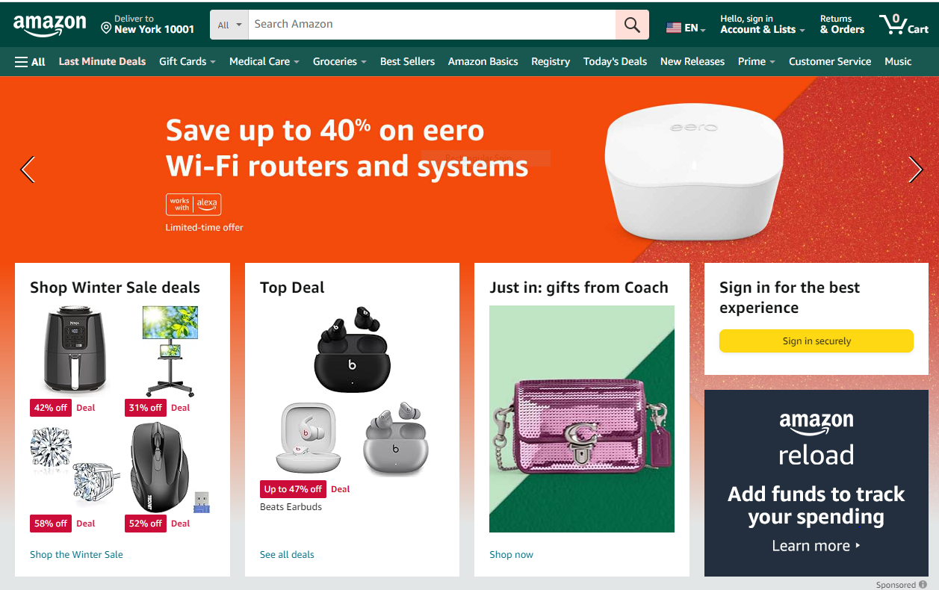**Step 1:**

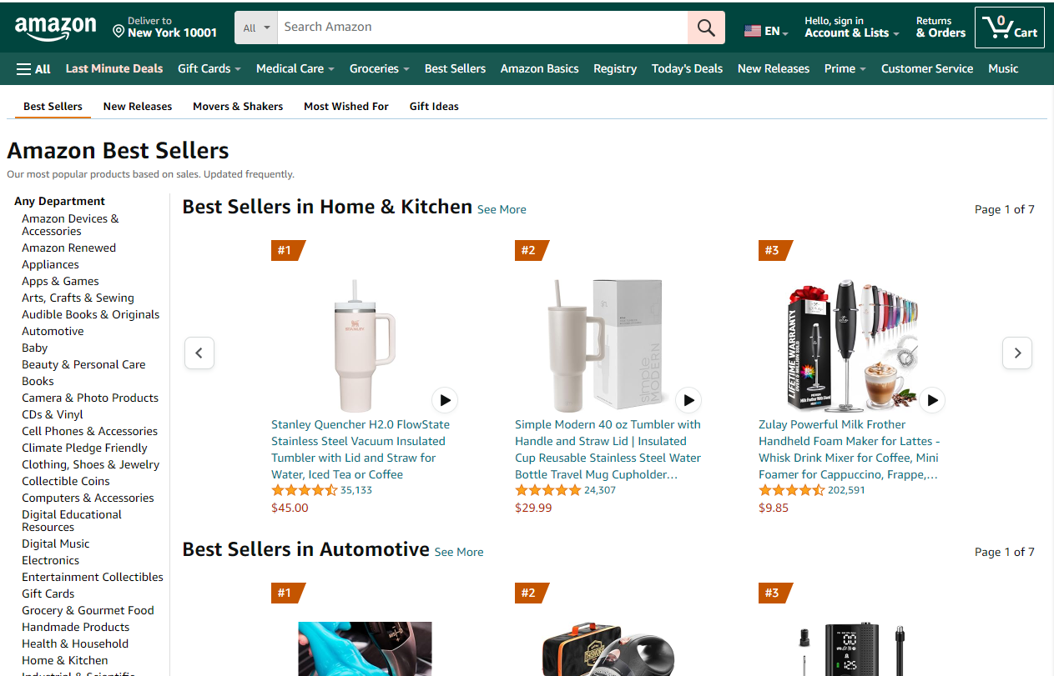**Step 2:**

**Open Home & Kitchen Category by clicking on see more.**

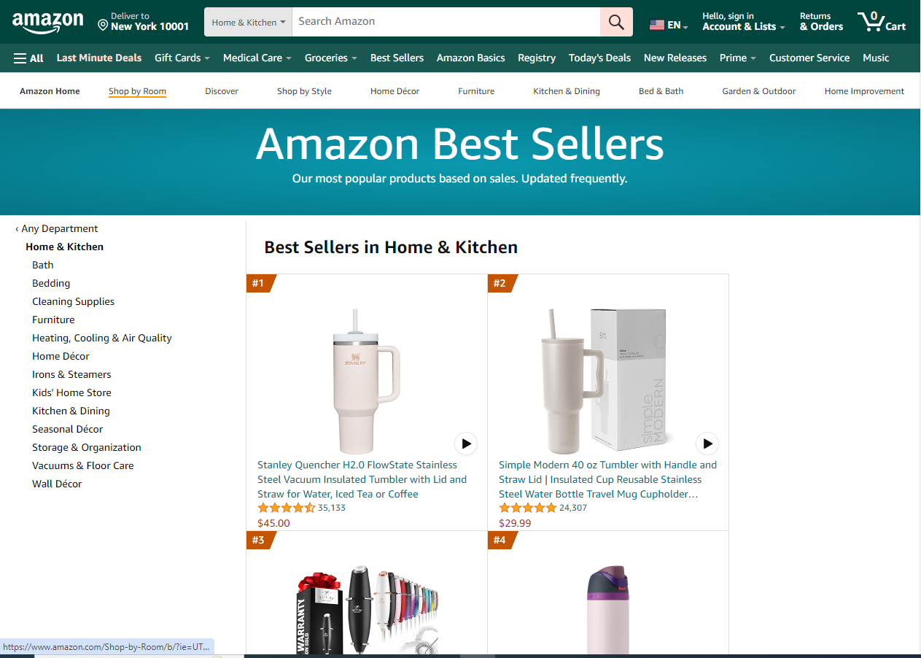**Step 3:**

**Open Products one by one & collect their brand names. Total 100 brands should be collected.**

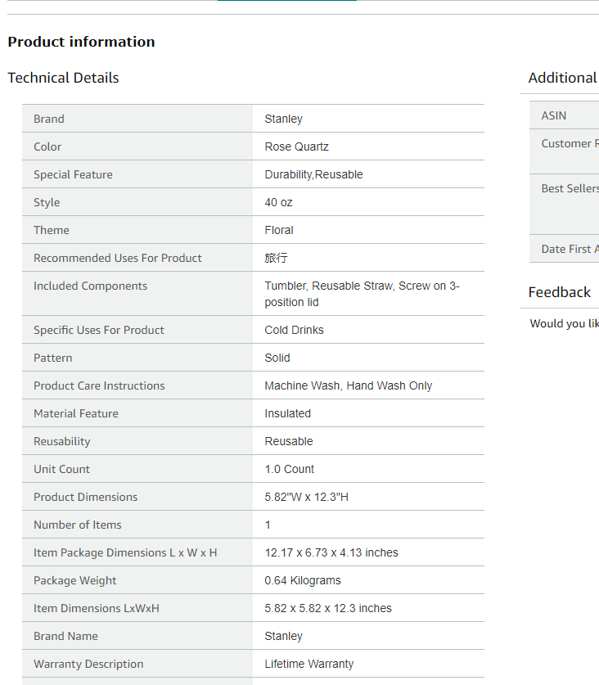**Step 4:**

**Open Product scroll down and you will find brand name in Product Information. Record these names in your Google Sheet**